Key words

|  |  |
| --- | --- |
|  |  |
| Avatar | An avatar is an image or username that represents a person online, most often within forums and social networks. |
| Average Handling Time | Average Handling Time is the average time required for a company or an individual to resolve their customer's issue or query on social media. |
| Augmented Reality (AR) | AR is the notion of adding computer generated elements, such as sounds, videos or GPS data, to the real world. These are typically done through some piece of technology like a smartphone or AR glasses. |
| Bitly | It is a free link management platform. It is mainly used to convert long URLs into a short link for social sharing. You can see the usage of such short links in Twitter or Instagram too. |
| Blog | Blog is a word that was created from two words: “web log.” |
| Chatbots | Chatbots are computer programs which conduct “human like” conversations with users, typically via text. They are typically used in Instant Messaging applications, such as Slack, or on websites to help users with frequently asked questions. |
| CTR (Click through rate) | Clickthrough rate is a common social media metric used to represent the number of times a visitor clickthrough divided by the total number of impressions a piece of content receives. |
| Conversion rate | Conversion rate refers to a common metric tracked in social media that is the percentage of people who completed an intended action (i.e. filling out a form, following a social account, etc.). |
| Creative common | Creative Commons is a nonprofit corporation dedicated to making it easier for people to share and build upon the work of others, consistent with the rules of copyright. It provides free licenses |
| Dark Data | Dark data is digital information that is not being used. Consulting and market research company Gartner Inc. describes dark data as "information assets that an organization collects, processes and stores in the course of its regular business activity, but generally fails to use for other purposes. |
| Employee Advocacy | Employee advocacy refers to the act of employees using their own social presence to increase the reach of the company and its content. |
| Endorsement | An endorsement on LinkedIn refers to an instance in which another LinkedIn user recognizes you for one of the skills you have listed on your profile. |
| Forum | known as a message board, a forum is an online discussion site. |
| Geotag | A geotag is the directional coordinates that can be attached to a piece of content online. For example, Instagram users often use geotagging to highlight the location in which their photo was taken. |
| Google Panda | Google Panda is a change to Google's search results ranking algorithm that was first released in February 2011. The change aimed to lower the rank of "low-quality sites" or "thin sites", in particular "content farms", and return higher-quality sites near the top of the search results. |
| Hashtag | A hashtag is a tag used on a variety of social networks as a way to annotate a message. A hashtag is a word or phrase preceded by a “#" (i.e. #InboundMarketing). Social networks use hashtags to categorize information and make it easily searchable for users. |
| In-game Advertising | Advertising popping up in between a game that you play is In-game Advertising and is majorly used by the brands to promote their products or services. |
| Inbound Link - | An inbound link is an incoming link to your site from another site. |
| Industry 4.0 | Industry 4.0 is the term which is surfacing to describe the current trend of automation and sharing of data in the manufacturing sectors.  The goal of this trend is to create “Smart Factories”, which are factories that analyze the way they work, make improvements to their processes through Machine Learning and then share their results with other factories so they can adapt as well. |
| Instagram | Instant Telegram |
| Linkedin | LinkedIn is a business-oriented social networking site with over 380 million members in over 200 countries and territories. Founded in December 2002 and launched in May 2003, it is mainly used for professional networking. |
| Lurker | A lurker online is a person who reads discussions on a message board, newsgroup, social network, or other interactive system, but rarely or never participates in the discussion. |
| Meme | A meme on the internet is used to describe a thought, idea, joke, or concept that's widely shared online. |
| Mirror Site | A site which has the same copied content of another website but with a different URL. |
| Podcast | Podcast is a digital audio file series created by a user and is available for download on the Internet. There are many artists or brands which became famous using Podcast. |
| Retargeting | Retargeting is an online marketing and advertising technique that allows marketers to display ads to people who have visited their website or are part of their contacts database. |
| Selfie | A selfie is a self-portrait that is typically taken using the reverse camera screen on a smartphone |
| Social Graph | The social graph is the collection of links, relationships, interactions and other connections that comprise a social network. |
| Social Selling | Social selling is a sales concept in which representatives leverage the power of social communication to engage with prospects by answering their questions, providing helpful content, clarifying information, etc. |
| Technological Unemployment | Technological Unemployment is the notion of humans losing jobs to machines. Advances in robotics, machine learning and automation have led to jobs being taken over by machines. |
| Tweetdeck | Tweetdeck is a Twitter tool that provides users with a way to manage their Twitter presence through custom columns. |
| Virtual Reality (VR) | Virtual Reality is similar to AR but it usually encompasses more of the user’s senses.  A user will typically wear goggles and headphones which block out the outside world and completely immerses them into the virtual reality created by the program. Examples include the Oculus Rift, the Google Daydream, or the PlayStation VR. |
| Vlogging | Vlogging or a vlog is a piece of content that employs video to tell a story or report on information. |
| Webinar | Online seminar |
|  |  |

9 Smart Social Media Tactics to Dominate 2018

<https://sproutsocial.com/insights/social-media-tactics/>

Carousel ad Facebook

<https://www.youtube.com/watch?v=wB6Xmt_Bpvs>

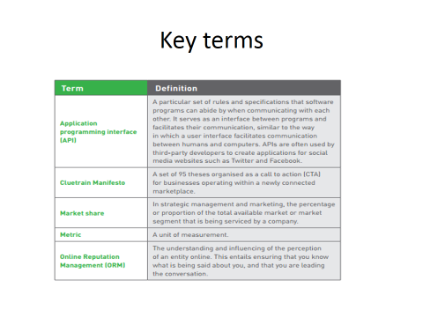

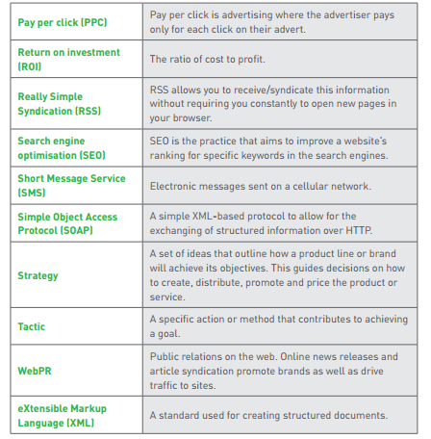

* NAP- network access point
* ISP- internet service provider
* IOT- Internet of Things
* VSAT- Virtual Satellite
* TCP/IP- Transmission Control Protocol (TCP) and the Internet Protocol (IP).
* SMTP- Simple Mail Transfer Protocol
* POP3- Post office protocol
* Middleware: Several different types of software that sit between and provide connectivity for two or more software  
  applications
* **Database access technology - e.g ODBC (Open DataBase Connectors)**
* **Java’s database connectivity API : JDBC**
* **Remote computation products - e.g ONC RPC, OSF RPC and RMI (Java Remote Method Invocation)**
* **Distributed Computing Environment (DCE) products, Common Object Request Broker Architecture (CORBA), Distributed Component Object Model (DCOM)**

**E-commerce**

A freight forwarder is a company that arranges shipping and insurance for international transactions

A customs broker is a company that arranges the payment of tariffs and compliance with customs laws for international shipments.

A bonded warehouse is a secure location where incoming international shipments can be held until customs requirements are satisfied or until payment arrangements are completed.

Electronic funds transfers (EFTs, also called wire transfers), which are electronic transmissions of account exchange information over private communications’ networks.

Electronic data interchange (EDI) occurs when one business transmits computer-readable data in a standard format to another business.

A value-added network (VAN) is an independent firm that offers connection and transaction-forwarding services to buyers and sellers engaged in EDI.

**Network**

A public network is any computer network or telecommunications network that is available to the public. The Internet is one example of a public network

A private network is a leased-line connection between two companies that physically connects their computers and/or networks to one another.

A leased line is a permanent telephone connection between two points.

A virtual private network (VPN) is a connection that uses public networks and their protocols to send data in a way that protects the data as well as a private network would, but at a lower cost.

IP tunneling creates a private passageway through the public Internet that provides secure transmission from one computer to another.

Plain old telephone service (POTS) uses existing telephone lines and an analog modem to provide a bandwidth of between 28 and 56 Kbps.

Today, most people use other connection methods, including a higher grade of telephone service called Digital Subscriber Line (DSL) protocol.

Bluetooth is useful for tasks such as wireless synchronization of laptop computers with desktop computers and wireless printing from laptops or mobile phones. These small Bluetooth networks are called personal area networks (PANs) or piconets.

The personal shopper is an intelligent agent program that learns the customer’s preferences and makes suggestions. The virtual model is a graphic image built from customer measurements and descriptions on which customers can try clothes